

**PROJECT**

**BUILDING NETWORK SYSTEM AT OFFICE**

Name : 1. Hilman Maulana Anhar

2. Muhamad Dani Setiawan

3. Muhammad Naufal Azmi

Faculty : Muhammad Idham Khalif, S.Kom

Semester : 1

Quarter : 1

Class : 1SC8

Continuing Education Center for Computing and Information Technology Faculty of Engineering, University of Indonesia

2018

PREFACE

First of all, thanks to Allah SWT because of the help of Allah, authors finished writing the paper entitled “Building Network System At Office” right in the calculated time.

The purpose in writing this paper is to fulfill the assignment that given by Mr. Muhammad Idham Khalif as our faculty in CEP-CCIT FTUI.

In arranging this paper, the writer truly get lots challenges and obstructions but with help of many individuals who can’t be mentioned one by one, those obstructions could have passed. writer also realized there are still many mistakes in process of writing this paper.

Because of that, the writer says thank to all individuals who helps in the process of writing this paper. hopefully Allah replies all helps and bless all. The writer realized that this paper is still not perfect in arrangement and the content. Then the writer hopes the criticism from the readers can help the writer in perfecting the next paper. Last but not the least Hopefully, this paper can help the readers to gain more knowledge about Building Secure Network.

Depok, 8 October 2018

Authors

**TABLE OF CONTENTS**

**PREFACE i**

**TABLE OF CONTENTS ii**

**TABLE OF FIGURES iii**

**TABLE OF TABLES iv**

**CHAPTER I INTRODUCTION 1**

1. Background 1
2. Writing Objective 2
3. Problem Domain 3
4. Writing Methodology 4
5. Writing Framework 5

**CHAPTER II BASIC THEORY 4**

1. Hardware Definition 4
2. Software Definition 4
3. Introduction To Networks 5
4. Network Architectures 6
5. Network Topology 7
6. Identifying Computer On A Network 9
7. Network Media 10
8. Network Device 11
9. Network Operating System 13

**CHAPTER III PROBLEM ANALYSIS 15**

1. Network Analysis 15
2. Network Architecture 18
3. Network Topology 18
4. Network Device 20
5. Software 27
6. Network Media 27
7. Cost 28

**CHAPTER IV CONCLUSION AND SUGGESTION 29**

1. Conclusion 29
2. Suggestion 29

**BIBLIOGRAPHY v**

**TABLE OF FIGURES**

Figure 2.1 Example of Network (REF: markijar.com) 5

Figure 2.2 Client-server Architecture (REF: markijar.com) 6

Figure 2.3 Peer-to-peer Architecture (REF: markijar.com) 6

Figure 2.4 Topology Bus (REF: markijar.com) 7

Figure 2.5 Topology Star (REF: markijar.com) 7

Figure 2.6 Topology Ring (REF: markijar.com) 8

Figure 2.7 Topology Mesh (REF: markijar.com) 8

Figure 2.8 Topology Tree (REF: markijar.com) 9

Figure 2.9 Router (REF: newegg.com) 11

Figure 2.10 Switch (REF: newegg.com) 11

Figure 2.11 Server (hp.com) 12

Figure 2.12 Access Point (REF: cisco.com) 12

Figure 2.13 IP Phone (cisco.com) 13

Figure 3.1 Network Scheme (REF: Analysis by Group) 17

Figure 3.2 Cisco 2811 Integrated Services Router (REF: cisco.com) 20

Figure 3.3 Cisco Catalyst 2960-24TT-L Switch (REF: cisco.com) 21

Figure 3.4 Cisco 7960 IP Phone (REF: cisco.com) 22

Figure 3.5 Epson L360 Printer (REF: epson.co.id) 23

Figure 3.6 Asus AiO V220ICGT-BG017X (REF: asus.com) 25

Figure 3.7 Asus Server TS500-E8/PS4 (REF: asus.com) 25

Figure 3.8 Belden CAT5E 305 Metres UTP Cable (REF: tokopedia.com) 26

**TABLE OF TABLES**

Table 3.1 Device Mapping (REF: Analysis by Group) 15

Table 3.2 IP Allocation (REF: Analysis by Group) 16

Table 3.3 Cost (REF: Analysis by Group) 28

**CHAPTER I**

**INTRODUCTION**

1. **Background**

Networking, also known as computer networking, is the practice of transporting and exchanging data between nodes over a shared medium in an information system. Networking comprises not only the design, construction and use of a network, but also the management, maintenance and operation of the network infrastructure, software and policies.

Computer networking enables devices and endpoints to be connected to each other on a local area network (LAN) or to a larger network, such as the internet or a private wide area network (WAN). This is an essential function for service providers, businesses and consumers worldwide to share resources, use or offer services, and communicate. Networking facilitates everything from telephone calls to text messaging to streaming video to the internet of things (IoT).

The level of skill required to operate a network directly correlates to the complexity of a given network. For example, a large enterprise may have thousands of nodes and rigorous security requirements, such as end-to-end encryption, requiring specialized network administrators to oversee the network.

At the other end of the spectrum, a layperson may set up and perform basic troubleshooting for a home Wi-Fi network with a short instruction manual. Both examples constitute computer networking.

In this project, we asked to design a network system. Therefore we choose to design an Office’s Network System. In this paper our group will explain how to create such network.

1. **Writing Objective**

This Project will be discussing about:

* Hardware Definition
* Software Definition
* Introduction to Networks
* Network Architecture
* Network Topology
* Identifying Computer on a Network
* Network Media
* Network Device
* Network Operating System
* Network Cost

1. **Problem Domain**

To keep this project topic focused, this document will explain about Hardware Definiton, Software Definition, What is Network, Network Architecture, Network Topology, Method to Identify a Computer on the Network, Network Media, Network Device, Network Operating System, How Much Does The Network System Cost.

1. Writing Methodology

The method used is the method of research with data collection techniques using observations from reliable media and source.

1. Writing Framework

To know the description of this paper, the authors divides it into four chapters. Each chapter in this study are interconnected between chapters with chapter one another by systematic writing as follows:

**CHAPTER I INTRODUCTION**

Tell about the Background, Writing Objective, Problem Domain, Writing Methodology, and Writing Framework

**CHAPTER II BASIC OF THEORY**

Tell about the Hardware Definition, Software Definition, Introduction To Networks, Network Architectures, Network Topology, Identifying Computer On A Network, Network Media, Network Device, Network Operating System

**CHAPTER III PROBLEM ANALYSIS**

Analyzing and solve the problem that contained in problem domain

**CHAPTER IV CONCLUSION AND SUGGESTION**

Conclusion and Suggestion things related to Project

CHAPTER II

BASIC THEORY

1. Hardware Definition

Hardware is a set of components in a computer whose job is to make the computer work. Or in other words hardware can also mean computer devices that can be touched, the contents are related to computer work systems.

This hardware is very useful for computers, because if there is no hardware there will be no computer that can be used. If your computer wants to be able to be normal then there must be 3 components, namely hardware, software and brainware. However, if one of these components does not exist, then your computer cannot be used.

Hardware functions:

* Input Hardware: is a hardware device that is used to enter data into a computer. Examples: Keyboard, Scanner, Mouse, Microphone, Web Cam and others.
* Process Hardware: is a set of hardware that functions to process data, in accordance with the instructions given by the operator, through Hardware Input. For example: CPU (Central Processing Unit).
* Output Hardware: this hardware acts as a device that displays processed data from Process Hardware. Examples: Monitor, Printer and Speaker.

1. Software Definition

Software is a collection of electronic data stored and regulated by a computer, electronic data stored by a computer can be a program or instruction that will execute a command. It is through software or software that a computer can execute a command.

Computer software can be put into categories based on common function, type, or field of use. There are three broad classifications:

* System Software is software that is designed and developed, to control hardware. Examples: operating systems and device drivers.
* Application Software is software that is used, to process data on a computer. Examples: Ms.Office, Adobe Photoshop, Corel Draw and others.
* Malware software is software, which is intentionally made to damage computer systems. Malware is also commonly used, as a tool for data theft. An example of this Malware itself is a virus.

1. Introduction to Networks

A network is a group of autonomous computers that are interconnected between one another, and use a communication protocol through communication media so that they can share and exchange information. example: such as CD ROM, Printer, File Exchange, or allows to communicate electronically.

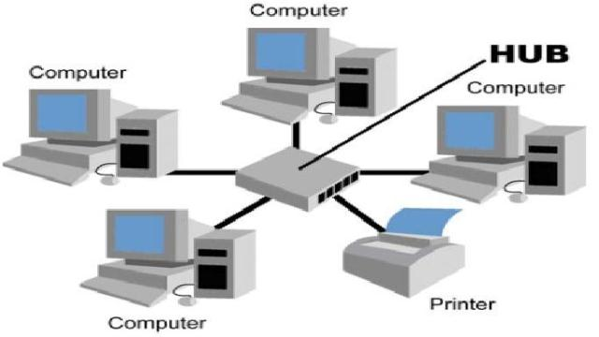

Figure 2.1 Example of Network (REF: markijar.com)

1. Network Architectures

Network architecture is the procedure for using hardware and software in a network so that one computer with another computer can communicate and exchange data. Network Architectures in general can be described into three categories :

* Client-Server

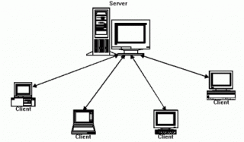

Figure 2.2 Client-server Architecture (REF: markijar.com)

A client is a receiving device that displays and runs applications (computer software) and the server is a device that provides and acts as the manager of the application, data, and security.

* Peer-to-peer

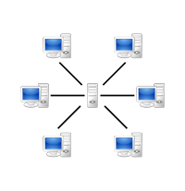

Figure 2.3 Peer-to-peer Architecture (REF: markijar.com)

Peer-to-peer is a computer network where each host can become a server and also become a client simultaneously.

2. Network Topology

Network topology is a way or concept to connect multiple or many computers at once into a network that is interconnected. Network topology in general can be described into five categories :

* Topology Bus

is a network that uses cable as a transmission medium or a central cable where all clients and servers are issued.

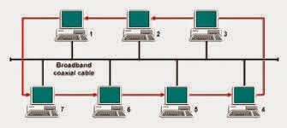

**Figure 2.4 Topology Bus (REF: markijar.com)**

* Topology Star

Topology Star is connecting between one computer with another computer in a computer network either the computer acts as a server or acts as a client. network star topology network can also be used to connect other network hardware such as routers, modems, access points and others.

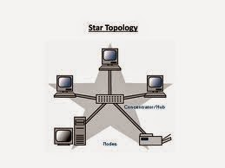

**Figure 2.5 Topology Star (REF: markijar.com)**

* Topology Ring

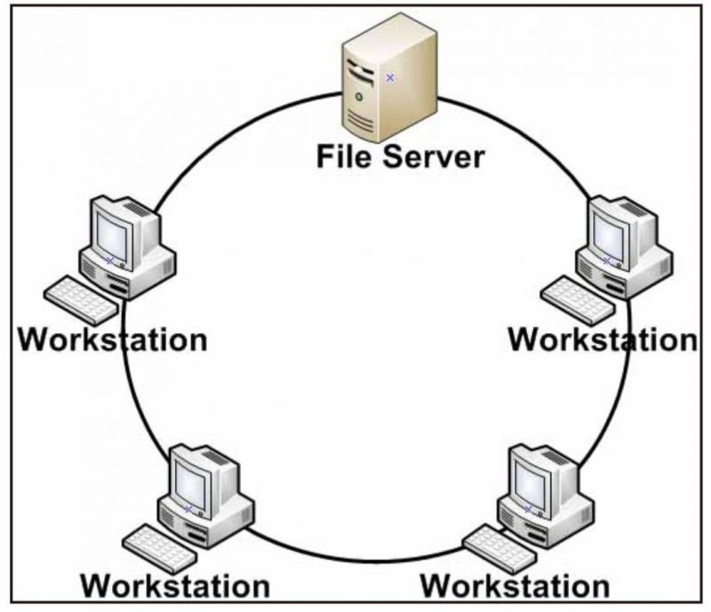 Topology Ring is a type of network topology in which the form of each circuit is connected to two other points, so that it can form like a ring.

**Figure 2.6 Topology Ring (REF: markijar.com)**

* Topology Mesh

Topology Mesh is a computer network where the form of connection between computer devices is directly connected to each other in one network.

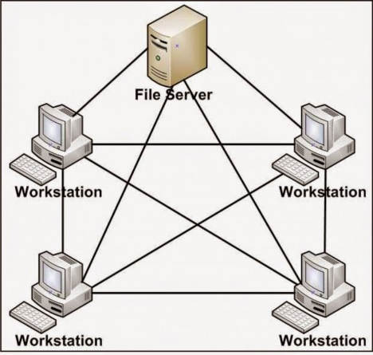

**Figure 2.7 Topology Mesh (REF: markijar.com)**

* Topology Tree

Topology Tree is a multilevel network topology and hierarchy which is between connections using a Hub / Switch and each Hub connected to a file server.

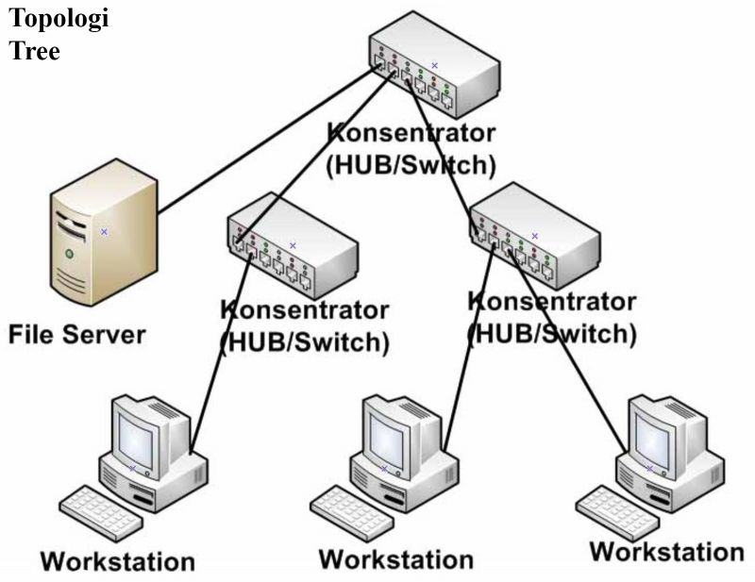

**Figure 2.8 Topology Tree (REF: markijar.com)**

1. **Identifying Computer On A Network**

Any computers on a network can be identified by this two following method.

* **IP Address**

An Internet Protocol address (IP address) is a numerical label assigned to each device connected to a computer network that uses the Internet Protocol for communication. An IP address serves two principal functions: host or network interface identification and location addressing.

* **MAC Addeess**

In a local area network (LAN) or other network, the MAC (Media Access Control) address is a computer's unique hardware number. (On an Ethernet LAN, it's the same as the computer’s Ethernet address.) When the user is connected to the Internet from the user’s computer (or host as the Internet protocol thinks of it), a correspondence table relates it’s IP address to the computer's physical (MAC) address on the LAN.

1. **Network Media**

Network media is the actual path over which an electrical signal travels as it moves from one component to another. I want to explain the common types of network media, including twisted-pair cable, coaxial cable, fiber-optic cable.

* **Twisted Pair Cable**

Twisted pair cable is can use for telephone communication and can cable ethernet networks. A pair of wires that can transmit data. When electronic signal through a wire, that create small magnetic field around a wire.

* **UTP Cable**

UTP cable is used for various networks. This cable include eight copper wires covered by an insulating material. UTP cable canceling effective of electromagnetic interference (EMI) and radio frequency interference (RFI). UTP cable is install using the Registered jack (RJ 45) connector. The RJ-45 has eight wire connector. UTP cable is used to connect local-area network (LAN).

* **Coaxial cable**

Coaxial cable is made of outer hollow conductor and inner wire made of two conducting element. The center of a cable is made of copper wire. Copper wire has surrounding by flexible insulation. Metallic foil is coted over the insulating called second layer. Second layer is reduce the amount of outside interference.

* **Fiber Optic Cable**

Fiber optic cable can carry more data in longer distance with light signal than electrinic signal carry coxial cable. Fiber optic cable can run 100km(60 miles) without amplifing the light signal.

1. **Network Device**

Network devices are components used to connect computers or other electronic devices together so that they can share files or resources like printers or fax machines. Devices used to setup a Local Area Network (LAN) are the most common type of network devicesused by the public. There are a lot of network devices but the writer will only focus to devices that are used by the Office’s Network.

* **Router**

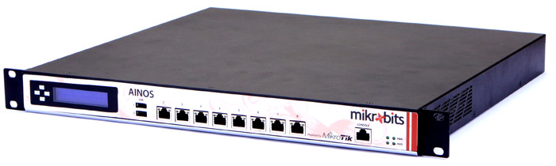

**Figure 2.9 Router (REF: newegg.com)**

Router is a network device which is responsible for routing traffic from one to another network. These two networks could be a private company network to a public network.

* **Switch**

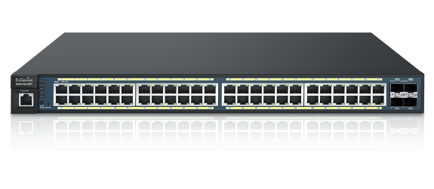

**Figure 2.10 Switch (REF: newegg.com)**

Switch works at the layer of LAN (Local Area Network). a switch does ‘filter and forwarding’ which is a more intelligent way of dealing with the data packets. A Good Switch able to perform VLAN configuration, VLAN is a group of devices on one or more LANs that are configured to communicate as if they were attached to the same wire.

* **Server**

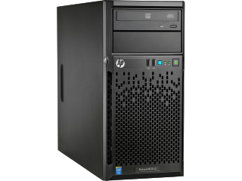

**Figure 2.11 Server (hp.com)**

Server is a computer designed to process requests and deliver data to other (client) computers over a local network or the internet. Although any computer running special software can function as a server, the most typical use of the word references the very large, high-powered machines that function as the pumps pushing and pulling data across the internet.

* 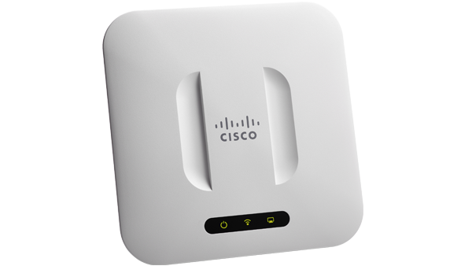**Access Point**

Figure 2.12 Access Point (REF: cisco.com)

Access point is a device that creates a wireless local area network, or WLAN, usually in an office or large building. An access point connects to a wired router, switch, or hub via an Ethernet cable, and projects a Wi-Fi signal to a designated area. For example, if you want to enable Wi-Fi access in your company's reception area but don’t have a router within range, you can install an access point near the front desk and run an Ethernet cable through the ceiling back to the server room.

* **IP Phone**

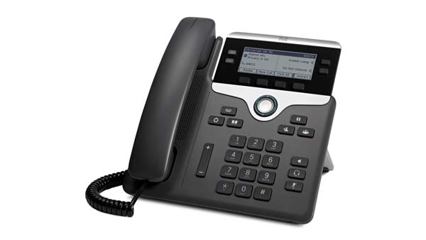

**Figure 2.13 IP Phone (cisco.com)**

The term "IP phone" refers to a telephone, which enables the processing of voice communication via the internet protocol and the internet or an intranet. One often speaks of so-called Voice-over-IP telephony (VoIP telephony) or VoIP telephones. The IP telephone converts analogue voice signals into digital signals and packages these in data packages that can be transferred via Internet Protocol.

1. **Network Operating System**

Network Operating System enable sharing of information and resource based on the accessibility privilege allocated to each user or device in the network.

Example of Network Operating System are :

1. **Windows Server 2012**

Is a server network operating system edition of the windows 8 os.

Comprises the following edition:

* Datacenter Edition
* Standard Edition
* Foundation Edition
* Essentials Edition

1. **Unix**

Unix Operating System is one of the earliest and most widely used network Operating Systems lauched by Bell Labs. It provides internet – based services and provides network security. Unix compatible with different protocol.

1. **Linux**

Linux is an open source OS developed by Linux Torvalds . It’s provides flexibility to the user modify the OS according to individual requirement. Linux can be customized and distributed by anyone to meet different business requirement.

1. **Solaris**

Solaries specifically design for e-commerce applications. It’s anages high-traffic network areas and incorporates security necessary for web transactions and support thousands of user of a time.Solaries is scalable as it can support a single processor to multi-processor System. It has utilities that are portable to all the platforms supported by Solaris.

**CHAPTER III**

**PROBLEM ANALYSIS**

1. **Network Analysis**

This Project is consists of Building a Network System at Office for creating ease access between each Employees or even Visitor. The Network Blueprints of the Office contains 1 CEO Room, 1 Receptionist Room, 2 Employees Room, and 1 Server Room. The Office’s CEO wants to create a Single Floor network that each employees can communicate via network, so the employees did not have to get out from their room also The CEO wants to have their own Server so the Employees can store Office Archives in the Local Server and accessible from the internet.

Below is the Blueprint of the Project :

1. **Device Mapping**

**Table 3.1 Device Mapping (REF: Analysis by Group)**

|  |  |
| --- | --- |
| CEO Room | * 1 PC * 1 IP Phone |
| Receptionist Room | * 1 PC * 1 IP Phone |
| Employee Room 1 | * 5 PCs * 1 Printer * 1 Switch |
| Employee Room 2 | * 5 PCs * 1 Printer * 1 Switch |

|  |  |
| --- | --- |
| Server Room | * 1 Server PC |
| Corridor | * 2 Switches * 1 Router |

1. **IP Allocation**

**Table 3.2 IP Allocation (REF: Analysis by Group)**

|  |  |  |
| --- | --- | --- |
| **Devices Name** | **IP Address** | **Subnet Mask** |
| **CEO Room**   * CEO PC * CEO Phone | 192.168.1.14  192.168.2.4 | 255.255.255.0  255.255.255.0 |
| **Receptionist Room**   * Receptionist PC * Receptionist Phone | 192.168.1.15  192.168.2.5 | 255.255.255.0  255.255.255.0 |
| **Employee Room 1**   * PC 01 * PC 02 * PC 03 * PC 04 * PC 05 * Printer 1 | 192.168.1.2  192.168.1.3  192.168.1.4  192.168.1.5  192.168.1.6  192.168.1.7 | 255.255.255.0  255.255.255.0  255.255.255.0  255.255.255.0  255.255.255.0  255.255.255.0 |
| **Employee Room 2**   * PC 06 * PC 07 * PC 08 * PC 09 * PC 10 * Printer 2 | 192.168.1.8  192.168.1.9  192.168.1.10  192.168.1.11  192.168.1.12  192.168.1.13 | 255.255.255.0  255.255.255.0  255.255.255.0  255.255.255.0  255.255.255.0  255.255.255.0 |
| **Server Room**   * Office Server | 192.168.1.1 | 255.255.255.0 |

1. 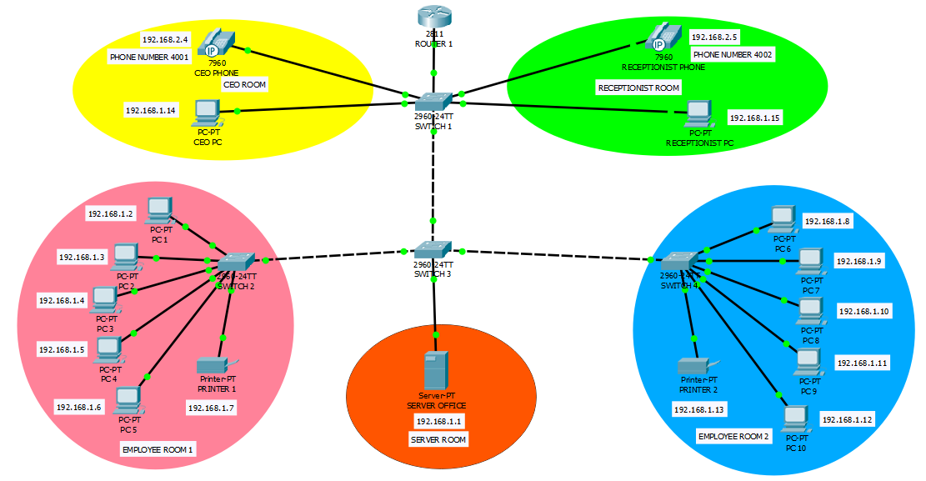**Network Scheme**

**Figure 3.1 Network Scheme (REF: Analysis by Group)**

1. **System Concept**

This system is mainly based on 1 Router and 4 Main switch, the First router work as the Internet Gateway and bridge the Server network to the office network. The main switch that placed on the Lobby is work as VLAN Gateway, it functions are to distribute VLAN ID to every switches at hospital.

Server Room is assigned with Class C IP 192.168.1.1/24, The reason of using this Class C is to anticipate the lacking of Reserved IP for users to access all devices. Things to note is the Main server are applied Load Balancing Method, it means the way of Server network connect to the internet is use the separate ISP from the other, to ensure availability and integrity.

1. **Network Architecture**

In this Project, the architecture that will be used in the Network is Client-Server Architecture, Client/server is a program relationship in which one program (the client) requests a service or resource from another program (the server).

Although the client/server model can be used by programs within a single computer, it is a more important concept for networking.  In this case, the client establishes a connection to the server over a local area network (LAN) or wide-area network (WAN). Once the server has fulfilled the client's request, the connection is terminated.

1. **Network Topology**

Because of there is lot of room in the Office, the Network requires a combination of more than one Topology. Based on that fact, the Network will use Hybrid as the Topology of the Network.

Hybrid, as the name suggests, is mixture of two different things. Similarly in this type of topology that integrate two or more different topologies to form a resultant topology which has good points (as well as weaknesses) of all the constituent basic topologies rather than having characteristics of one specific topology. This combination of topologies is done according to the requirements of the organization.

Of course this kind of topology have advantages and disavantages:

* **Advantages**

**Reliable:** Unlike other networks, fault detection and troubleshooting is easy in this type of topology. The part in which fault is detected can be isolated from the rest of network and required corrective measures can be taken, without affecting the functioning of rest of the network.

**Scalable:** Its easy to increase the size of network by adding new components, without disturbing existing architecture.

**Flexible:** Hybrid Network can be designed according to the requirements of the organization and by optimizing the available resources. Special care can be given to nodes where traffic is high as well as where chances of fault are high.

**Effective:** Hybrid topology is the combination of two or more topologies, so we can design it in such a way that strengths of constituent topologies are maximized while there weaknesses are neutralized. For example we saw Ring Topology has good data reliability (achieved by use of tokens) and Star topology has high tolerance capability (as each node is not directly connected to other but through central device), so these two can be used effectively in hybrid star-ring topology.

* **Disavantages**

**Complexity of Design:** One of the biggest disadvantage of hybrid topology is its design. Its not easy to design this type of architecture and its a tough job for designers. Configuration and installation process needs to be very efficient.

**Costly Hub/switches:** The hubs used to connect two distinct networks, are very expensive. These hubs are different from usual hubs as they need to be intelligent enough to work with different architectures and should be function even if a part of network is down.

**Costly Infrastructure:** As hybrid architectures are usually larger in scale, they require a lot of cables, cooling systems, sophisticate network devices, etc.

1. **Network Device**

There are lot of network devices with various functionality, however, the Office’s Network needs these Devices :

1. 1x Cisco 2811 Integrated Services Router

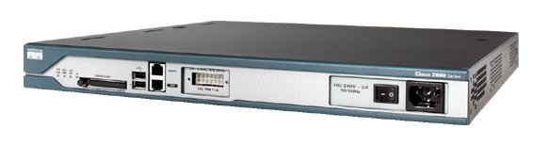

**Figure 3.2 Cisco 2811 Integrated Services Router (REF: cisco.com)**

The Cisco 2811 Integrated Services Router is part of the Cisco 2800 Integrated Services Router Series which complements the Integrated Services Router Portfolio. The Cisco 2811 Integrated Services Router provides the following support:

* Wire-speed performance for concurrent services such as security and voice , and advanced services to multiple T1/E1/xDSL WAN rates
* Enhanced investment protection through increased performance and modularity
* Increased density through High-Speed WAN Interface Card Slots (four)
* Enhanced Network Module Slot
* Support for over 90 existing and new modules
* Support for majority of existing AIMs, NMs, WICs, VWICs, and VICs
* Two Integrated 10/100 Fast Ethernet ports
* Optional Layer 2 switching support with Power over Ethernet (PoE) (as an option)
* Security
  + On-board encryption
  + Support of up to 1500 VPN tunnels with the AIM-EPII-PLUS Module
  + Antivirus defense support through Network Admission Control (NAC)
  + Intrusion Prevention as well as stateful Cisco IOS Firewall support and many more essential security features
* Voice
  + Analog and digital voice call support
  + Optional voice mail support
  + Optional support for Cisco CallManager Express (Cisco CME) for local call processing in stand alone business for up to36 IP Phones
  + Optional support for Survivable Remote Site Telephony support for local call processing in small enterprise branch offices for up to 36 IP phones

1. 4x Cisco Catalyst 2960-24TT-L Switch

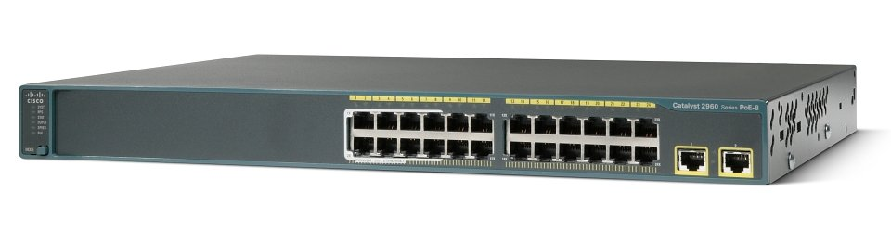

**Figure 3.3 Cisco Catalyst 2960-24TT-L Switch (REF: cisco.com)**

The Catalyst 2960 Series offers the following benefits:

* Intelligent features at the network edge, such as sophisticated access control lists (ACL) and enhanced security.
* Dual-purpose uplinks for Gigabit Ethernet uplink flexibility, allowing use of either a copper or a fiber uplink. Each dual-purpose uplink port has one 10/100/1000 Ethernet port and one SFP-based Gigabit Ethernet port, with one port active at a time.
* Network control and bandwidth optimization through advanced QoS, granular rate-limiting, ACLs, and multicast services.
* Network security through a wide range of authentication methods, data encryption technologies, and network admission control based on users, ports, and MAC addresses.
* Easy network configuration, upgrades, and troubleshooting as part of the mid-market or branch solution using the embedded Device Manager and Cisco Network Assistant.
* Auto-configuration for specialized applications using Cisco Smartports.

1. 2x Cisco 7960 IP Phone

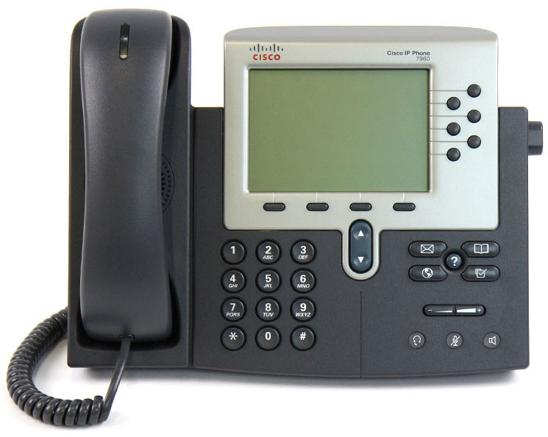

**Figure 3.4 Cisco 7960 IP Phone (REF: cisco.com)**

The Cisco IP Phone 7960, a key offering in the IP Phone portfolio, is a full-featured IP phone primarily for manager and executive needs. It provides six programmable line/feature buttons and four interactive soft keys that guide a user through call features and functions. Audio controls for duplex speakerphone, handset and headset. The Cisco Unified IP Phone 7960G also features a large, pixel-based LCD display. The display provides features such as date and time, calling party name, calling party number, and digits dialed. The graphic capability of the display allows for the inclusion of such features as XML (Extensible Markup Language) and future features.

1. 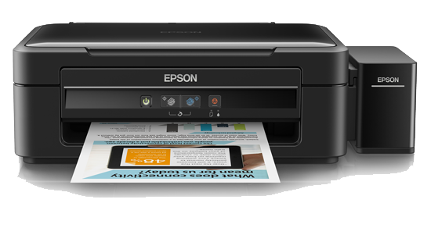2x Epson L360 4.Printer

**Figure 3.5 Epson L360 Printer (REF: epson.co.id)**

* Superb Print Speeds

Speed is key when it comes to meeting the challenges of deadlines and driving up your business performance. Powered by the Micro Piezo™ printhead technology, discover exceptional print speeds of up to 9.2ipm for default black and white prints, and 33ppm for draft black and white. High volume printing has never been this quick and efficient.

* Low Costs, High Yield

Don’t compromise on cost as you print. With Epson’s original ink tank system, you’ll be able to save costs as each bottle of ink costs only Rp 75,000 and each set has an ultra-high yield of 7,500 for colour or 4,500 pages for black. With a patented bottle tip

design to allow easy and mess-free refills, tubes in the printer are also designed to be of optimum width to ensure smooth and reliable ink flow at all times.

* Epson Warranty for Peace of Mind

Enjoy Epson’s warranty coverage of up to two years or 30,000 prints, whichever comes first, for maximum value from your printer. Epson’s warranty includes coverage of printhead, which is most important for a printer designed for high volume printing.

* Astounding Print Quality

An astoundingly high resolution of 5760 dpi delivers exceptionally high quality prints for all your personal and creative needs.

* One-touch Scan and Copy

Conveniently perform scan and copy functions with a reliably precise sensor. Scans are sharp and clear while draft mode copies are completed in a matter of seconds.

* Space-saving Design

The L360 is designed for small spaces. Its compact footprint means you can fit it comfortably anywhere in your office or home, creating an ergonomic work environment.

* Quality that Shines. Value that Lasts.

Epson genuine ink bottles are formulated to deliver outstanding high-volume print quality with L-series printers. Every bottle is individually sealed to ensure the purity of ink and comes with a smart tip designed for mess-free refills. Choose Epson genuine ink bottles to enjoy lasting quality with your L-series printer and low printing cost.

1. 12x Asus All In One V220ICGT-BG017X

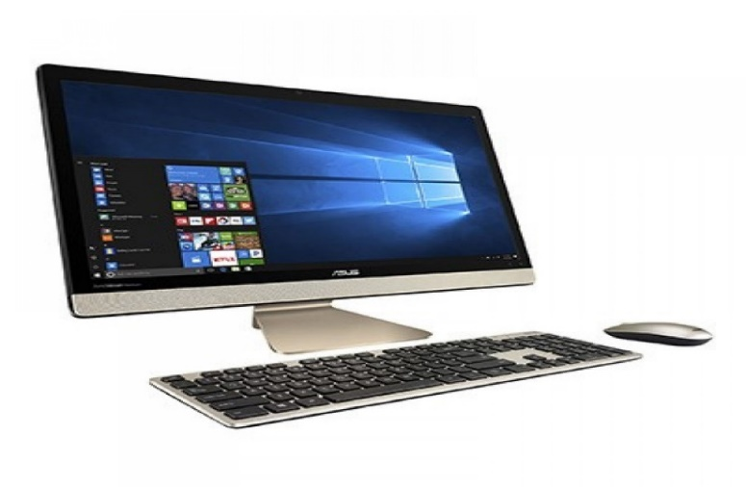

**Figure 3.6 Asus AiO V220ICGT-BG017X (REF: asus.com)**

The stunningly beautiful Vivo AiO V220 all-in-one PC is the slimmest-ever Vivo AiO, with a truly extraordinary audio system. Featuring advanced audio technology that includes transmission-line speakers and smart amplifiers, Vivo AiO V220 immerses you in amazingly powerful, high-quality sound for the ultimate multimedia experience.

1. 1x Asus Server TS500-E8/PS4

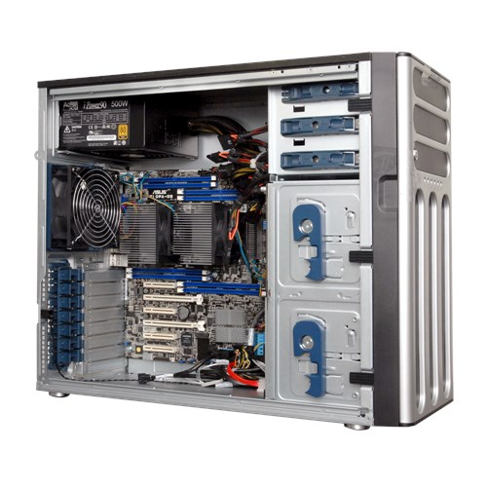

**Figure 3.7 Asus Server TS500-E8/PS4 (REF: asus.com)**

TS500-E8-PS4 is the mainstream Tower server perfectly built for both workstation and server dual use. It features the latest Intel® Xeon® processor E5-2600 v3 product families, 8 DIMMs, six expansion slots, three 5.25” media bays and single 500W 80 PLUS Bronze power supply. Additionally, as other E8 series server, TS500-E8-PS4 V2 equips the premium components offering up to 94% VR efficiency as well as the complete remote management solution.

1. 5x Belden CAT5E 305 Metres UTP Cable

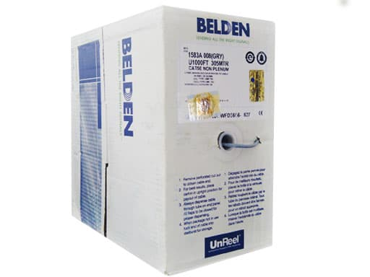

**Figure 3.8 Belden CAT5E 305 Metres UTP Cable (REF: tokopedia.com)**

Belden Cable has a good reputation among network engineers, it have good signal strength, improved signal-to-noise performance and, larger copper.

1. **Software**

In this specific Project, the Office’s network will require stability, reliability, and effectiveness. Based on that statement, the Network will use Windows 10 Professional as the Client Operating System, and Windows Server 2016 for the Server’s Operating systems, below is the reason why the network should use those two mentioned Operating System.

* **Windows 10 Professional**

Stability and overall performance of this OS is why many people choose this as their main desktop operating system. This OS is relatively new and got many support from it’s developer, Microsoft Corporation. Also the win 10 is already included on the AIO PC so the network did not cost additional expense for any closed-source host OS.

* **Windows Server 2016**

Microsoft Windows Server 2016, previously referred to as Windows Server vNext, is a server operating system (OS). The server operating system is specifically developed to serve as a platform for running networked applications.

* **Microsoft Office 365 Personal**

Office 365 is the brand name Microsoft uses for a group of software and services subscriptions, which together provide productivity software and related services to subscribers. For consumers, the service allows the use of Microsoft Office apps on Windows and macOS.

1. **Network Media**

The office will use only one network media, Wired. The wired network is required for connecting a room with another.

1. **Cost**

**Table 3.3 Cost (REF: Analysis by Group)**

|  |  |  |  |
| --- | --- | --- | --- |
| **Device Name** | **Qty** | **Price (IDR)** | **Total Price** |
| Cisco 2811 Integrated Services Router | 1 | Rp 2.500.000 | Rp 2.500.000 |
| Cisco Catalyst 2960-24TT-L Switch | 4 | Rp 5.500.000 | Rp 22.000.000 |
| Cisco 7960 IP Phone | 2 | Rp 2.750.000 | Rp 5.500.000 |
| Epson L360 Printer | 2 | Rp 2.160.000 | Rp 4.320.000 |
| Asus All In One V220ICGT-BG017X | 12 | Rp 10.400.000 | Rp 124.800.000 |
| Asus Server TS500-E8/PS4 | 1 | Rp 31.380.000 | Rp 31.380.000 |
| Belden CAT5E 305 Metres UTP Cable | 5 | Rp 1.220.000 | Rp 6.100.000 |
| Windows 10 Professional | 1 | Rp 2.110.000 | Rp 2.110.000 |
| Windows Server 2016 | 1 | Rp 10.699.000 | Rp 10.699.000 |
| Microsoft Office 365 Personal | 1 | Rp 580.000 | Rp 580.000 |
|  |  | Total : | Rp 209.989.000 |

**CHAPTER IV**

**CONCLUSION AND SUGGESTION**

1. Conclusion

Network is a Collection of devices that connected to one another, thus creating an integrated connection, in order to create a network, first thing is to overlook a Topology and the Architecture and decide the media and device used within the Network.

In the Office, a Network Engineer must think smartly how to build a stable, secure network. Hybrid Topology provide flexible connection allowing the Engineer to add more devices aswell as forgiving network failure without disturbing the whole network.

Office needs a management software to ease up the employees. As for the network cost, the Network Engineer must press the budget as small as possible, choosing the inexpensive but powerful devices is a must.

1. Suggestion

Even with the Complexity of the Network setup, it can not guaranteed 100% safety, to anticipate it is recommended for the Administrators to perform a weekly data backup, to anticipate the Network Failure caused by user error or a Natural Disaster.

**BIBLIOGRAPHY**

Rouse, Magaret. 2010. *“Networking (computer)”,* https://searchnetworking.techtarget.com/definition/networking [3 October 2018]

*“TS500-E8-PS4”*, https://www.asus.com/Commercial-Servers-Workstations/TS500E8PS4  
[5 October 2018 ]

*“Vivo AiO V220IC”*, https://www.asus.com/All-in-One-PCs/Vivo-AiO-V220IC/ [5 October 2018]

*“Epson L360 All-in-One Ink Tank Printer”,* https://www.epson.co.id/For-Home/Printers/Ink-Tank/Ink-Tank-System/Epson-L360-All-in-One-Ink-Tank-Printer/p/C11CE55501 [5 October 2018]

*“Cisco 2811 Integrated Services Router”*, https://www.cisco.com/c/en/us/support/routers/2811-integrated-services-router-isr/model.html [5 October 2018]

*“Cisco Catalyst 2960-24TT-L Switch”,* https://www.cisco.com/c/en/us/support/switches/catalyst-2960-24tt-l-switch/model.html [5 October 2018]

*“Cisco Unified IP Phone 7960G”,* https://www.cisco.com/c/en/us/products/collaboration-endpoints/unified-ip-phone-7960g/index.html [6 October 2018]

*“Computer Basics Hardware Types of hardware”,* http://wikieducator.org/Computer_Basics/Hardware/Types_of_hardware [6 October 2018]

*“8 Topologi Jaringan Komputer”,* http://www.markijar.com/2015/09/8-topologi-jaringan-komputer-lengkap.html [8 October 2018]